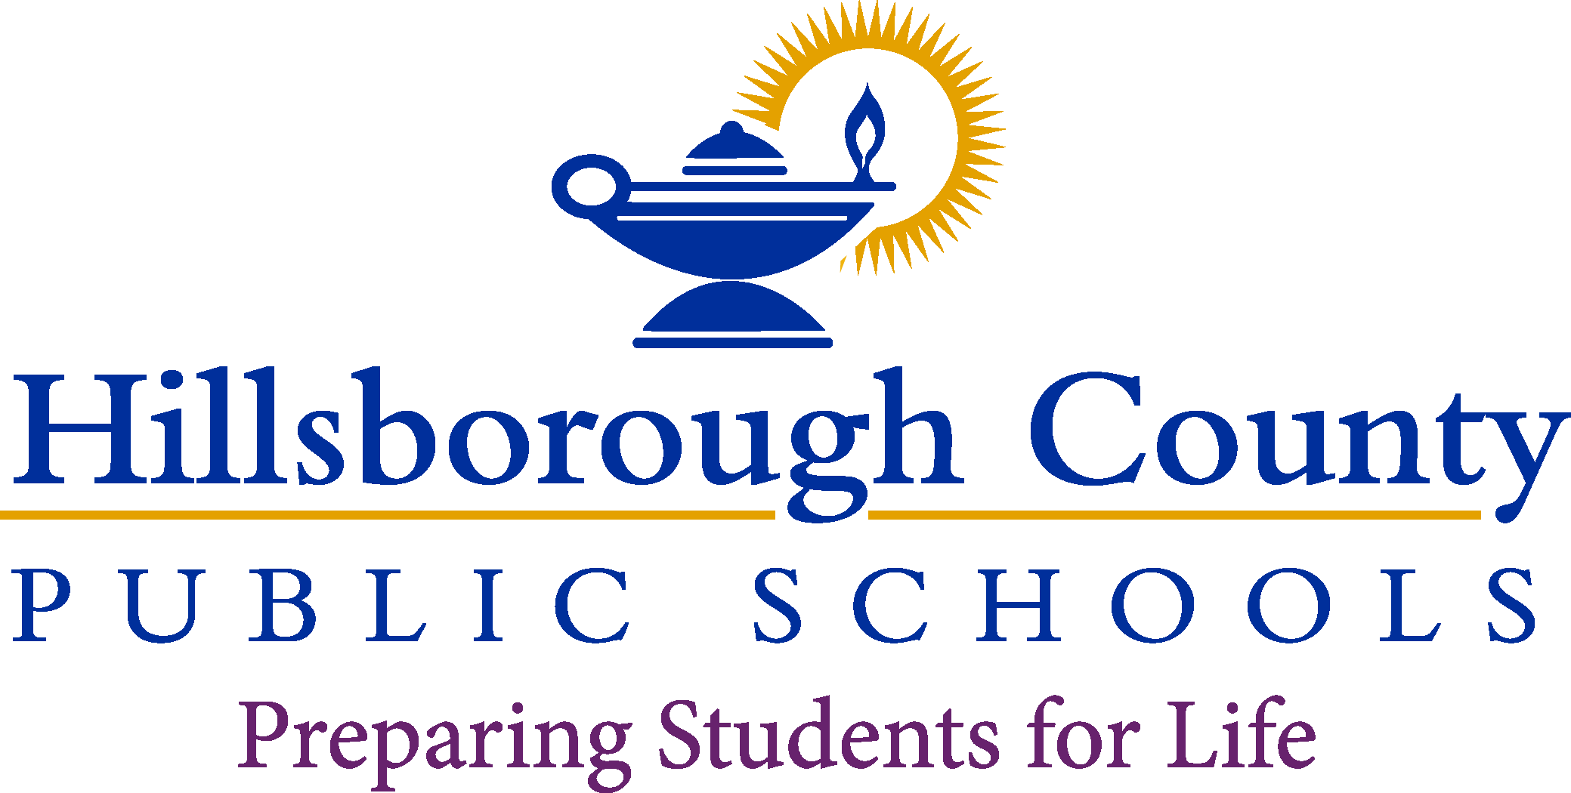

**Interim Superintendent**

Van Ayres

**Principal**

Kelly Simmons

**Assistant Principal**

Beth Silva

**School Board**

Nadia T. Combs, Chair

Henry “Shake” Washington, Vice Chair

Lynn L. Gray

Stacy A. Hahn, Ph.D.

Karen Perez

Patricia “Patti” Rendon

Jessica Vaughn

August 07, 2023

Dear Parent/Guardian:

Florida State Statute 1012.42, when a teacher is assigned teaching duties out of field in which the teacher is certified, the parents of all students in the class shall be notified in writing.

Hillsborough County Public Schools is committed to providing quality instruction for all students and does so by employing the most qualifies individuals to teach and support each student in the classroom. The district is assisting our teachers by developing an Individual Professional Development All educators in Florida are monitored to ensure they meet certification and training requirements as mandated by law. Per Plan to complete the requirements needed to become in-field.

All our teachers are certified to teach, although some of them are currently out-of-field and are working on additional areas of certification. You have the right to know the professional qualifications of the teachers or paraprofessionals who instruct your child. Federal law allows you to ask for certain information about your child's teachers and requires us to give you this information in a timely manner if you ask for it. If you would like more information, please contact the school at (813)975-7355.

The table below lists the teachers who are currently out of field.

Sincerely,

Kelly Simmons

Principal, Dorothy Thomas School

|  |  |  |  |  |
| --- | --- | --- | --- | --- |
| Teacher | Classes Taught  Assignment(s) | Assignment  Start date | Certification(s)  Held | Out of field  Area /Classes |
| Gremli-Sanders, Maria | Nutrition & Wellness  Family & Consumer Science  Prin. of Food Prep  Business | August 10,2023 | Business  Education  6-12 | Nutrition & Wellness  Family& Consumer Science  Prin. of Food Prep |